Article

A Smart System for Continuous Sitting Posture Monitoring and Assessment

David Faith Odesola 1, Janusz Kulon 1* and, Shiny Verghese 1, Adam Partlow 2, and Colin Gibson 2

|  |
| --- |
| **Citation:** To be added by editorial staff during production.  Academic Editor: Firstname Lastname  Received: date  Revised: date  Accepted: date  Published: date    **Copyright:** © 2024 by the authors. Submitted for possible open access publication under the terms and conditions of the Creative Commons Attribution (CC BY) license (https://creativecommons.org/licenses/by/4.0/). |

1 Faculty of Computing, Engineering and Science, University of South Wales, Pontypridd, CF37 1DL, UK; 30025293@students.southwales.ac.uk; j.kulon@southwales.ac.uk; shiny.verghese@southwales.ac.uk

2 Rehabilitation Engineering Unit, Cardiff and Vale University Health Board, CF37 5TF, UK

Adam.Partlow@wales.nhs.uk; Colin.Gibson@wales.nhs.uk

* Correspondence: j.kulon@southwales.ac.uk

**Abstract: <<**TO BE FILLED>>.

**Keywords:** sitting posture classification, smart-sensing chair, machine learning, posture monitoring

1. Introduction

1.1 Background and Motivation

In this present day and age, sedentary behaviors such as prolonged sitting has become a fundamental part of one’s lifestyles, especially among office workers. These individuals most often find themselves confined to a desk, in front of a computer screen for an extended period; a pattern that has proven to be detrimental to one’s health [1,2]. According to the World Health Organization (WHO), the economic burdens attributed to sedentary behaviors is costing an estimate of around US$ 27 billion annually and is expected to reach US $300 billion by the year 2030 [3].

The adoption of an improper sitting postures such as slouching and asymmetric sitting is a contributing factor that further increases the risk of several other health issues, ultimately negatively affecting one’s quality of life. This bad habit is not just prevalent among the elderly population, but also across individuals within different age groups [4]. Such pattern over a long-term period, could thereby lead to the development of chronic health issues such as lower back pains [5] and other musculoskeletal conditions [6]. Hence, it is typically advised by doctors and healthcare professionals to consistently maintain an upright sitting posture which involves having your back in a straight position or perpendicular to the chair’s backrest. Furthermore, in addition to maintaining an upright sitting posture, it is also recommended to avoid sitting for a long period of time or minimizing the maintaining a singular posture for a long duration [7,8]. A few walking breaks are usually recommended within a certain period during the day.

Furthermore, to help combat this issue, various researchers have explored the use of smart sensing chair systems capable of detecting various sitting postures to further encourage the adoption of proper sitting habits. So far, there are varying methods being employed in the development of such systems ranging from different classification methods, sensor types, senso placement strategies and feedback mechanisms. Sitting is a continuous task that often changes and varies among individuals of different bodily structure. Hence, the incorporation of corrective feedback systems is crucial in both promoting and recommending proper sitting habits on a per-user basis. A recent study by our team [9] highlighted a notable gap in the current research landscape which saw that the vast majority of studies primarily focuses on the detection of different sitting postures and achieving high classification accuracies while not giving little to attention on the feedback mechanism. Enhancing the feedback mechanism by providing valuable postural analysis as well as actionable insight will surely be deemed useful towards the end user.

The primary aim of this study is to design and develop a smart chair system capable of classifying different sitting postures using a machine learning model. This paper also aims to develop a comprehensive posture feedback system which captures sitting posture data and intelligently provides a score them while providing relevant insights back to the end-user.

2. Related Works

Over the recent years, there has been a constant rise in the number of research studies conducted on sitting posture detection and monitoring system. This growing attention among researchers highlights this research’s potential of driving significant change by positively impacting postural habits among individuals, subsequently improving the quality of life [9]. Currently, there are 2 main categories of posture monitoring devices, wearable devices and non-wearable devices. Wearable devices are systems which are fitted with sensors which must be always worn to capture real-time postural readings, mainly focusing on the spinal area. These sensors are typically small and are often integrated into clothing wear which must constantly have bodily contact. Due to its highly invasive nature, many individuals may find it quite uncomfortable and disruptive to their daily activities. In terms of the practicality of such systems among the general population, it is of great importance consider areas such energy consumption, portability and its non-invasiveness [10]. Inertial sensors such as IMUs (Inertial Measurement Unit) which are normally comprised of gyroscopes, accelerometers and sometimes magnetometers are popularly used to capture an individual’s bodily measurements. Here are some of the existing devices found [11–13].

On the other hand, there are the non-wearable solutions which do not require an individual to wear any special clothing or device. These systems are non-invasive by nature are meant to capture postural measurements without being disruptive towards the end user in any way. Within this research field, there are various methods being employed such as the use of camera-based systems and sensor-infused sitting mats. Camera-based systems work by a having a set of cameras which meant to capture multiple reference points of the human body such as the head, shoulders and the hips to detect different postures[14–16]. This typically functions by having one or more cameras placed at different point of view to effectively capture all the bodily points. For this to work effectively, there must be no obstruction between the camera’s view and the subject being assessed, and there must always be proper lighting available. Overall, this suggests that the viability of camera-based systems primarily depends on a properly controlled environment, making it an un-popular option among research studies [10]. Another common method of implementation is the use of sensor-infused sitting mats which goes notion of having one or more sensors integrated into the backrest and the seating area of a chair. As the user seats and subtly moves about the chair, the system can both capture and identifying the different postures being adopted. Some of the commonly used sensors are pressure sensors, load cells, and flex sensors. One of the first research papers published that pioneered the idea of a smart sensing chair system was by Tan el. [17] back in 2001. They were able to classify 14 different siting postures using a (Principal Component Analysis)-based algorithm which interfaced with pressure sensor array module placed the both the back rest and the sitting area of the chair; achieving an overall accuracy ranging between 79% to 96%. Subsequently, a lot of research studies has been published primarily following a very similar approach. Wang et al. [18] developed a smart chair system equipped with a (9x9) & (10x9) FSR pressure matrix which were used to classify up to 15 different sitting postures using the SNN (Spike Neural Networks). Tsai et al [19]. adopted a similar approach by using a textile-based pressure sensor array to classify 7 sitting postures while achieving an overall classification accuracy of 85.9%. In the research space, there are various classification methods being employed such as rule-based techniques [20,21], statistical models (K-Nearest Neighbors (KNNs) [22–25], Decision Tree [26–28], Support Vector Machines (SVMs) [19,29,30], Random Forests (RFs) [31–33]), and deep learning models (Convolutional Neural Networks (CNNs) [34–36], and Artificial Neural Networks (ANNs) [21,37–39]).

A well-constructed feedback mechanism is primarily aimed to both inform and encourage an individual to adopt “proper” sitting postures along with providing valuable postural insights that would improve their overall sitting habits. Within the current research landscape, there are multiple ways that a user can receive valuable feedback. Mobile phones have been emerging as a popular medium for collecting and displaying useful feedback back to the end user. Cai et al. [40]. developed a smart sensing chair system which relayed the detected posture via a mobile app. Additionally, Cho et al. [41] also developed a similar mobile app which provided statistical insights along with recommended YouTube videos largely based on the sitting postures being adopted. Ran et al. [37] and Ishac et al. [42] integrated haptic motors into the seating cushion which vibrated whenever an improper sitting posture is being detected which continues until an upright posture has been achieved by the individual. On the other hand, Ren et al. [43] incorporated the use of a RGB led light strip which changed in color whenever the individual needed to change their sitting posture and taking microbreaks.

Overall, it was seen that the feedback mechanism implemented among similar studies were severely lacking mainly in providing informative elements and actionable insights. Ideally this should encourage individuals of both adopt and maintain proper sitting postures. However, most systems are more focused on simply displaying the current posture being adopted without any form of valuable feedback mechanism. While most smart-sensing systems can detect and identify various sitting postures, there are some feature sets that are absent such as real-time feedback and posture scoring mechanism which would rate and provide a score on the current posture being adopted. From the end user’s perspective, is there any certainty that the implemented feedback system has achieved its goal of inciting adopting of proper sitting postures? Furthermore, with the lack of comprehensive feedback of such systems, a lot of questions can be raised regarding both its usability and effectiveness in a real-life setting. Hence, there is a need for a comprehensive system in place to access whether the implemented feedback mechanism has achieved its desired expectations.

3. Methods and Design

3.1 Design Requirements

This paper will be focusing on the development of smart sensing chair capable of classifying different sitting postures using a commercially available pressure sensor array. This smart sensing chair aims to classify nine sitting postures as shown in Figure 1. Additionally, a novel feedback software application will be developed to provide valuable insights regarding the sitting postures being adopted over a period.

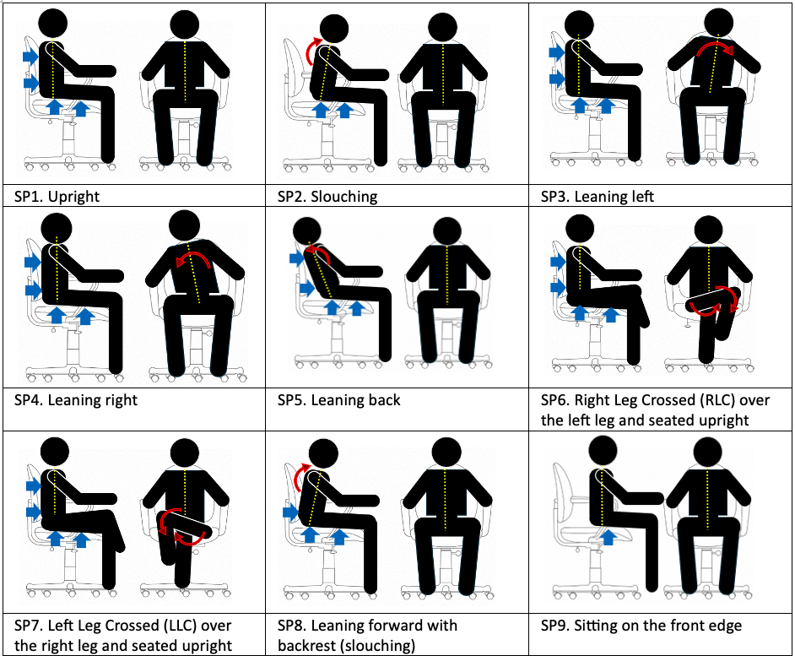

Figure **1**. The nine variations of sitting postures that will be adopted in this research study. (**SP1**) Upright, (**SP2**) Slouching, (**SP3**) Leaning Left, (**SP4**) Leaning Right, (**SP5**) Leaning Back, (**SP6**) Right leg crossed over the left leg and seated upright, (**SP7**) Left leg crossed over the right leg and seated upright, (**SP8**) Leaning forward with backrest, (**SP9**) Sitting on the front edge.

3.2 System Model

The entire conceptual framework of our posture monitoring system is as shown in Figure 2 below. The individual while during the experiment will be instructed to sit in various sitting posture as previously highlighted in previous section. During that period, the attached PC was used to both capture and save the sensor data along with its associated timestamp. After the data for each is posture has been thoroughly captured, we proceed with training on a series of machine learning models. Multiple machine learning models were examined to determine its classification accuracy which consist of the following Naïve Bayes, Random Forest, Decision Tree, SVM, Gradient Boosting, KNN, and CNN. Each machine model was trained on the same dataset under the same conditions to ensure a fair comparison among them. This training and the testing phase were executed using Google Colab platform.

Additionally, we constructed a web-based application that allowed us to effectively visualise the posture data and all relevant information. The web interface was programmed using the Flutter (Dart), which is an open-source framework supports multi-platform application such as iOS, Android, and Desktop under a single codebase. We also developed a backend API that used with our trained models which subsequently delivered the posture predictions in a JSON structure; This allowed our web application to easily query our its output and display the necessary graphs.



**Figure 2**. The entire system model the smart sensing chair system

3.2 State of the Art Pressure Sensor Array

In order to comprehensively capture the individual’s sitting pattern, 2 CONFORMat pressure sensor arrays were installed on the chair’s backrest and seating cushion area. The CONFORMat sensor mat is a commercially available device that was developed by Tekscan [44] shown in Figure 3. Each sensor mat is composed of 1024 independent pressure units, distributed over a 471.4 mm x 471.4 mm area. There are a total of 32 units on both the x-axis and the y-axis. The value for each pressure units ranges between 0 and 255. The sensor mat also comes equipped with a data acquisition module, called the Evolution handle™ device which facilitate the data transfer between the sensor array and a PC computer via a tethered USB cable. A summarized technical specification list is provided in Table 1 below.



**Figure 3**. 2 (32x32) Tekscan CONFORMat Sensor along with a data acquisition module

**Table 1**. CONFORMat sensor mat’s technical specifications [45]

|  |  |
| --- | --- |
| **Technical Specification** | **Details** |
| System Model | CER2 (CONFORMat Sensor) |
| Sensor Model | 5330 |
| Quantity | 2 |
| Sensing Area | 471.4 mm x 471.4 mm  (18.56 in. x 18.56 in.) |
| # of Sensing Elements | 2048 (1024 on each mat) |
| Pressure Range | 34 kPa (5 psi) |
| Spatial Resolution | 0.5 Sensel/cm2 (3.0 Sensels/in2) |

3.1 Experimental Setup

As previously stated, 2 CONFORMat pressure sensor arrays were used in this experiment; one placed on the backrest and the other on the sitting cushion as shown in Figure 4 below. Each of the Evolution handle™ devices were carefully attached to the side of the chair and the linked USB cable was plugged into a Windows PC to collect the sensor data.



**Figure 4**. Office chair fitted with 2 Tekscan CONFORMat Pressure Mats.

3.2 Data Collection

In our experiment, we collected our dataset from (one) individual. The subject was directed to sit in nine different sitting postures highlighted in Figure 1. Each posture was sat on for approximately 25 seconds as we recorded and saved the sensor data. Figure 5 below provides a visual representation of the sensor data in respect to the different sitting postures being adopted. Overall, a total of 200 frames of sensor data was captured for each given posture, equating to a total of 1000 sets of data.

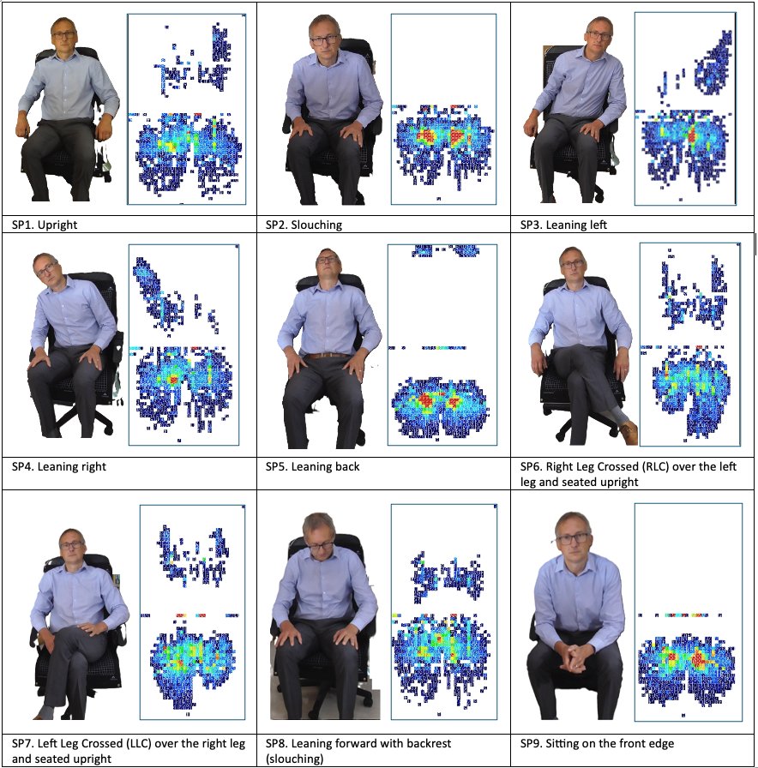

**Figure 5**. The capturing of nine different sitting postures data along with its pressure distribution representation.

It must be highlighted that our data collection approach is different from other studies as we are focused on collecting posture data from single individual rather than from a diverse set of participants with varying physical attributes. The main reasoning behind this approach is that we want to experiment the notion of having the machine learning model specifically trained to a specific individual, instead generalizing it. Hence, potentially making it more precise and applicable towards the user.

3.3 Machine Learning Algorithms

Multiple machine learning models were examined to determine its classification accuracy which consist of the following Naïve Bayes, Random Forest, Decision Tree, SVM, Gradient Boosting, KNN, and CNN. Each machine model was trained on the same dataset under the same conditions to ensure a fair comparison among them.

[DUPLICATED BELOW]

3.5 Posture Monitoring and Scoring System

Actively monitoring and scoring of different sitting postures are important to quantify the quality of one’s sitting patterns over a given period. In order to generate a score for each posture, we had to set a baseline for what is considered as an optimal sitting posture. As previously stated, it is normally advised to always maintain an upright sitting posture due to the associated health benefits. Furthermore, the upright sitting posture was considered as the base reference for all other postures. As shown in Figure ___, we designed an algorithm using the Hausdorff distance to determine the extent a given sitting posture shapes deviates from our base upright posture. The Hausdorff distance formula is computed as the following:

$$d_{H\left(A, B\right)}= \backslash max \{ \backslash sup_{\left\{a ∈A\right\}∈f_{\left\{b ∈B\right\}d\left(a, b\right)}}, \backslash sup_{\left\{b ∈B\right\}∈f_{\left\{a ∈A\right\}d\left(b, a\right)\}}}$$

[Explanation for each symbol here]

When comparing two shapes using the Hausdorff distance, one of the main drawbacks seen is that the positions between both shapes in the 2D space is a contributing factor. Essentially, this means that any translation or shifts between 2 shapes can have a profound impact in the calculation for the Hausdorff distance. Hence, to tackle this issue, we added an additional pre-processing step which automatically adjust the placements of 2 shapes to its optimal position using the Procrustes analysis. Procrustes analysis is a method used to compare shapes by performing optimal transformation procedures such as scaling, translation and rotations in respect to the reference shape as shown in an example in Figure 6. The primary of objective of the Procrustes analysis is to find the degree of transformation required such that the points in the X axis best corresponds with the Y axis. By doing this we were able to make our system more robust and effective in calculating the Hausdorff distance between 2 sitting posture shapes.



**Figure 6**. An example of the Procrustes analysis being performed on 2 shapes of different transformations.

4. Results and Discussion

4.1 Performance of the Machine Learning Algorithm

As previously stated, 80% of the entire dataset was used to train the machine leaning models, while the remaining 20% was used to evaluate the accuracy of the models. Table 2 provides a summary in regards to the classification accuracy of each machine learning model. Overall, it was seen that a high classification accuracy was achieved across all models ranging from 96% to 99.50%. SVM had the lowest accuracy of them all at 91.50% meanwhile, KNN, Gradient Boosting, and MLP had highest accuracies which was at 99.50%.

**Table 2**. Classification of the machine learning models using the testing dataset.

|  |  |
| --- | --- |
| **Model** | **Accuracy** |
| Naïve Bayes | 96% |
| Random Forest | 99% |
| Decision Tree | 99.50% |
| Support Vector Machine (SVM) | 91.50% |
| K-Nearest Neighbor (KNN) | 99.50% |
| Gradient Boosting | 99.50% |
| Multilayer Perceptron (MLP) | 99.50% |

Figure 6 below shows the confusion matrix of the seven machine learning models that were examined. The confusion matrix is a method used to evaluate the performance of machine learning model by comparing its predicted values against the original testing dataset. As expected, the machine learning model that performed the worst was SVM. From Figure 6, it is seen that it consistently mistook other sitting postures for the “leaning right” position, however other simpler models such as Decision Trees and Naïve Bayes performed a lot better.

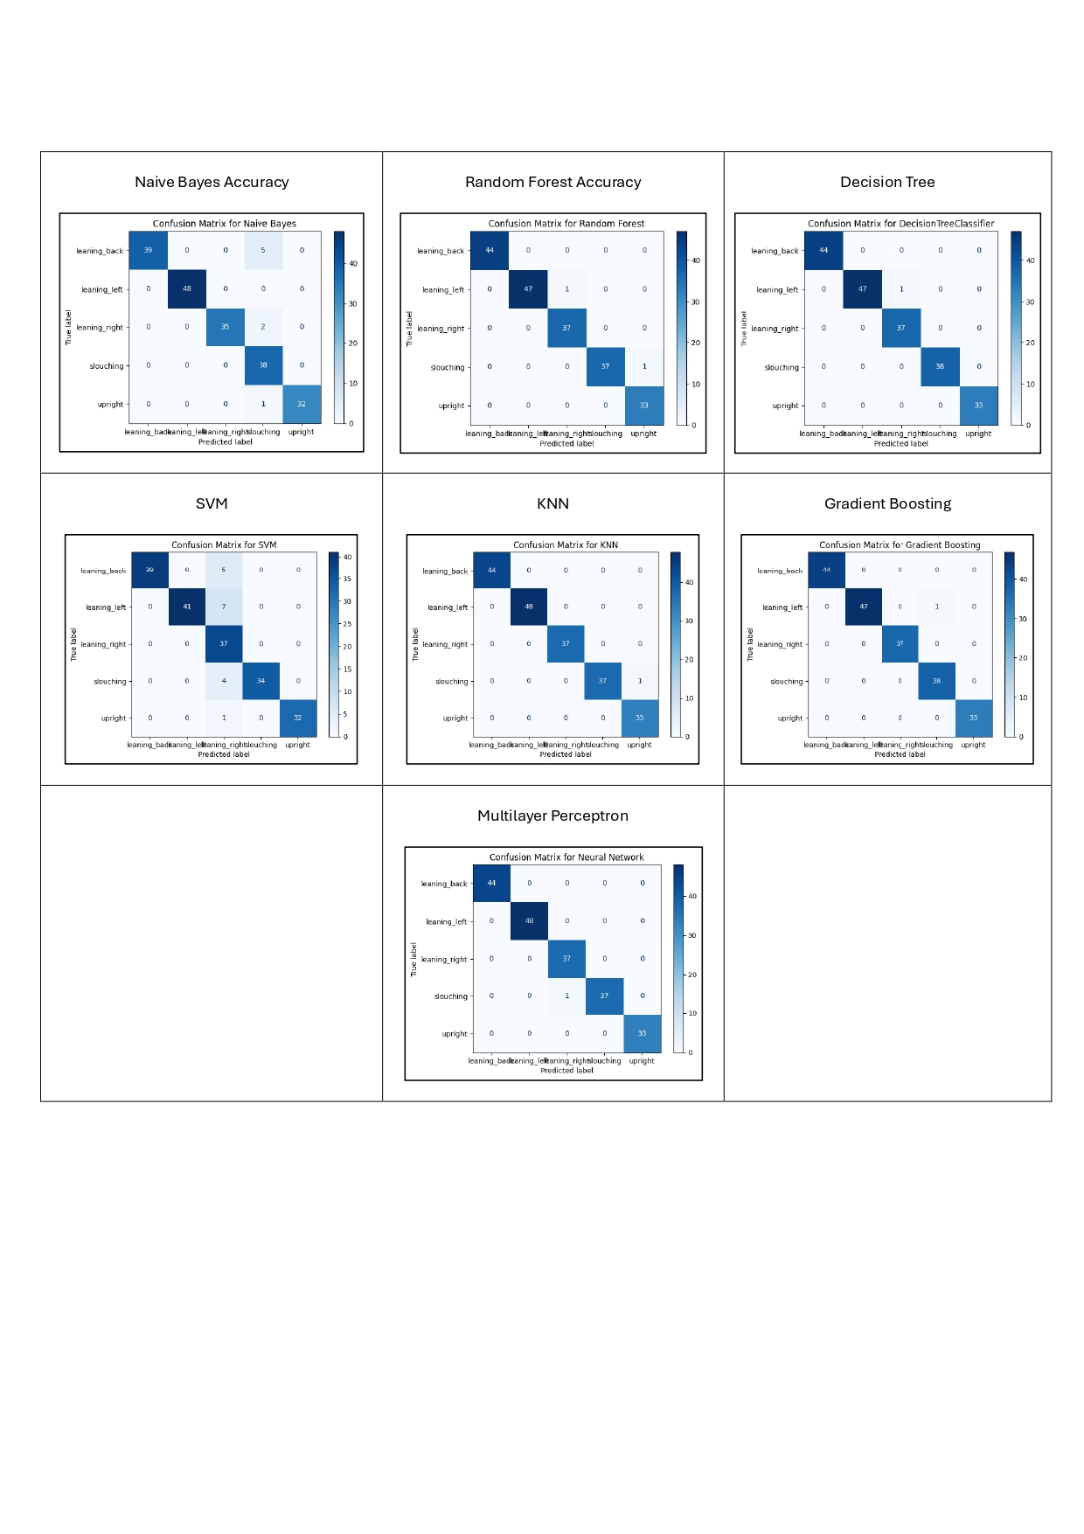

**Figure 7**. Confusion Matrix for each machine learning model.

Figures 8 shows the learning curve among each of the machine learning models. Focusing on the Naïve Bayes, it was seen that there was a steep decline in the training score as more training data was fed into the model, but then settles at ~95%. This phenomenon was also seen on the SVM model. This suggests that both machine learning models have been underfitted hence why their training accuracies were gradually declining has more data was added. On the other hand, the rest of machine learning models had a near perfect training score during the entire training phase, except for the KNN which had a slight dip at the start. Additionally, their validation accuracy scores at the beginning started off relatively low and gradually improved has more datasets were added which resulted in a high classification accuracy for the different sitting postures.

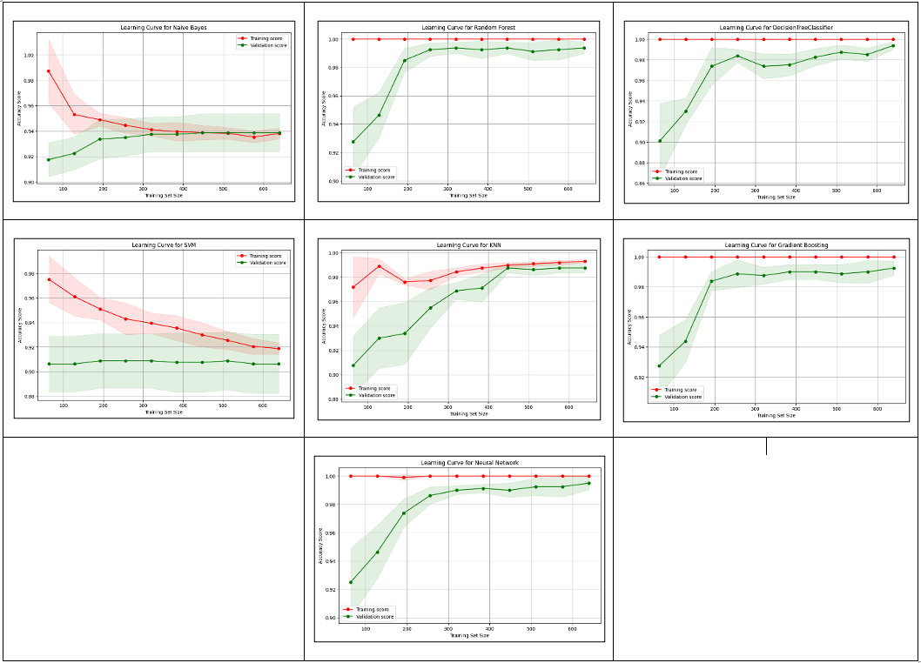

**Figure 8**. The learning curves for each machine learning model.

Given that each of our sensor array mat has a given resolution of 32x32 measuring to 1024 pressure units. There was a need for us to understand whether a resolution of this size is necessary to be able to accurately classify multiple sitting postures. The question that needed to be answered is would a lower sensor resolution be able to have the same level of accuracy as the higher resolution sensor? To answer this question, we lowered the sensor resolution from the original (32x32) size using the bilinear interpolation algorithm. Multiple simulated sensor sizes (2x2, 3x3, 5x5, 10x10, 20x20, 25x25) were tested against multiple machine learning models. The relationship between the classification accuracy and the sensor’s resolutions can be found in Figure 9. Overall, it seen that the classification accuracy to some extent is dependent on the sensor resolution. As the resolutions increase, the, the classification accuracy increases. It is apparent that most of the machine leaning models struggled with lower resolutions especially the ones with 2x2, 3x3, and 5x5 resolutions. This suggests that they do not provide enough information or features to reliably identify different sitting postures. This as a result caused the models to perform relatively poorly compared to those of higher resolutions which captures relevant spatial information of one’s sitting posture. It is also seen that the 10x10 array size is sufficient for most machine learning models to accurately distinguish between different sitting postures with a near-perfect accuracy. Machine models such as the Decision Tree, Random Forest, Gradient Boosting, KNN, and MLP were able to achieve accuracies upwards of 98%, at par with other higher sensor resolution sizes such as the (20x20), (25x25), and (32x32). This therefore suggests that the (10x10) resolution size more than sufficient to capture one’s without compromising on accuracy.

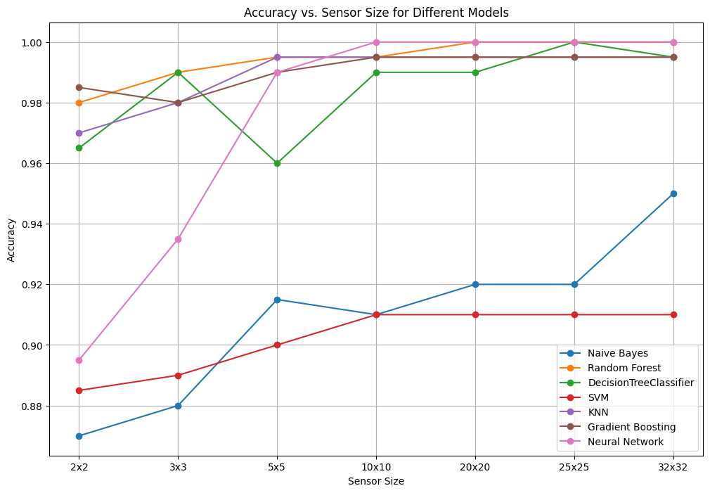

**Figure 9**. A graph comparing the accuracies of different machine learning models in respect to different sensor sizes.

4.1 Feedback Mechanism

A web-based feedback mechanism was developed which visualised and provided all the necessary insights regarding sitting postures being adopted. After training the machine learning model, we decided to use and integrate the MLP model into our feedback interface. The feedback interface didn’t rely on real-time data from sensor mat, we instead decided to programmatically generate different simulated sitting postures, which fed into our trained machine learning model to generate its prediction. In the top left section of the screen in Figure 10 there is the simulated pressure mat, which provides a heat map visualization of the sensor data in regard to the different postures being simulated. Just below the sensor array is a drop-down selection that allows one to adjust the density of the simulated pressure mat. In the background, linear interpolation was used to translate it to a 32x32 resolution which the machine leaning model was originally trained on. At the lower left “Simulated Posture“ section, there is a another dropdown option which allows various simulated postured to be adopted. Next to it is the Timer which visualizes the amount of time spent using the application. The graph in the “Sitting Pattern” section displays one’s sitting pattern over time.



**Figure 10**. First tab of the Sitting Posture Dashboard

In the second tab, there are 4 (Sitting Quality, Statistics, Predicted Posture, and AI Recommendation) sections. In the Sitting Quality section, there is a line graph that visualizes the overall quality of sitting over a given period based off a derived formula which is as follows:

Sitting Quality Formula and Explanation.

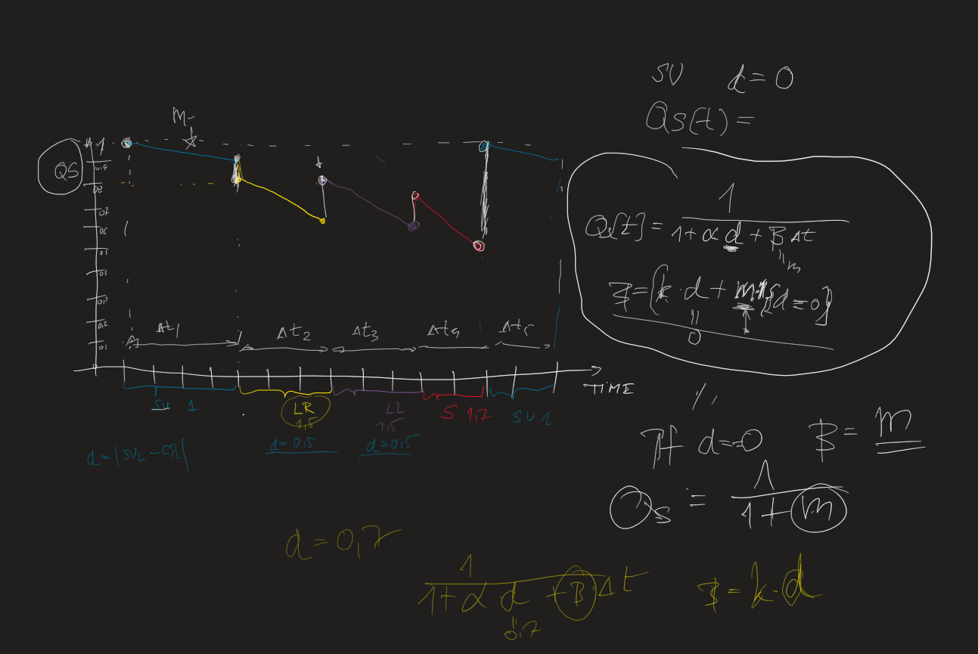

The Statistics section provides a statistical insight in regard to the popularity of postures being simulated using a pie chart. To the right of it is the machine leaning model’s predicted sitting posture which the simulated data was inputted with. In process to obtain valuable insights on the data being collected, an AI recommendation section was added which utilized OpenAI’s GPT-4 Large Language Model (LLM) model to generate personalized recommendations. The prompt that was fed in simply instructed the model to provide a short paragraph based on the duration that each postured was simulated in. Figure 12 below provides the prompt sent to the LLM model and the response that was generated back.



**Figure 11**. Second tab of the Sitting Posture Dashboard

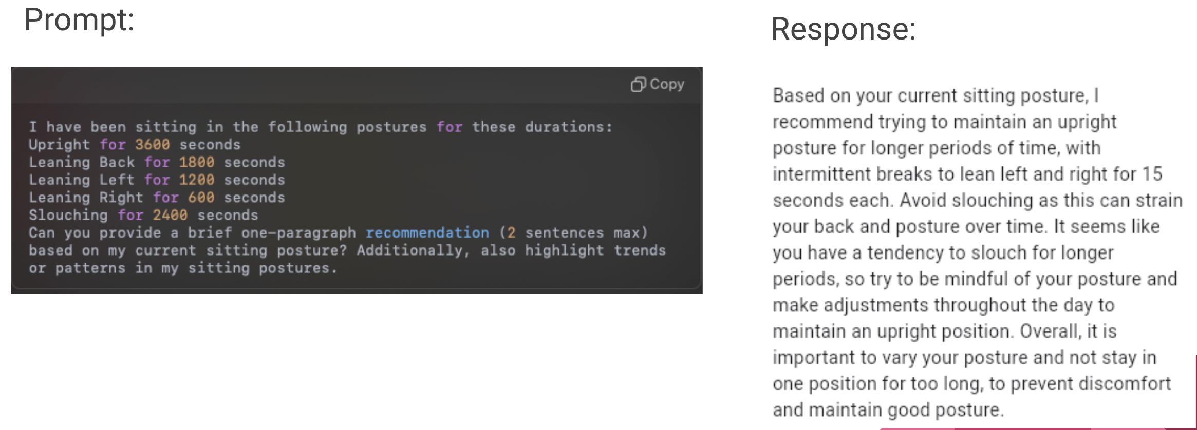

**Figure 12**. The prompt and the response using OpenAI’s GPT-4 model in generating recommendations.

At the top section of the third tab are 2 gauges which displays the Hausdorff distance that was calculated for both the backrest and the seat areas.

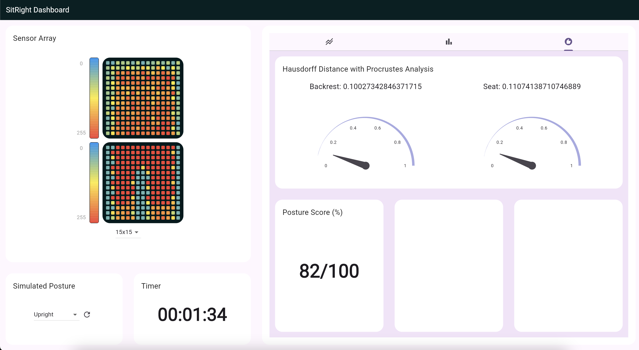

**Figure 13**. Third tab of the Sitting Posture Dashboard

4.2 Effectiveness of the Posture Monitoring System

4.3 Statistical Analysis of Sitting Patterns

4.4 Interpretation of Results

4.5 Limitations of the Study

4. Discussion

5. Conclusions

This is the conclusion section

**Supplementary Materials:** The following supporting information can be downloaded at: www.mdpi.com/xxx/s1, Figure S1: title; Table S1: title; Video S1: title.

**Author Contributions:** <Author’s contributions>

**Funding:** This work was partly supported by the University of South Wales (USW) QR fund (ref: 104607.13.1125), RIS funding (ref: 104790.1125), and Cardiff & Vale University Health Board, Rehabilitation Engineering Unit (REU), contributions (ref: 103914.13.1122).

**Institutional Review Board Statement:** Not Applicable.

**Informed Consent Statement:** Not Applicable.

**Data Availability Statement:** We encourage all authors of articles published in MDPI journals to share their research data. In this section, please provide details regarding where data supporting reported results can be found, including links to publicly archived datasets analyzed or generated during the study. Where no new data were created, or where data is unavailable due to privacy or ethical restrictions, a statement is still required. Suggested Data Availability Statements are available in section “MDPI Research Data Policies” at https://www.mdpi.com/ethics.

**Acknowledgments:** The authors would like to thank the University of South Wales and Cardiff & Vale University Health Board, REU, for supporting the project.

**Conflicts of Interest:** The authors declare no conflicts of interest.

**Appendix A**

Appendix content

**Appendix B**

Appendix content

References

1. Daneshmandi, H.; Choobineh, A.; Ghaem, H.; Karimi, M. Adverse Effects of Prolonged Sitting Behavior on the General Health of Office Workers. *J Lifestyle Med* **2017**, *7*, 69–75, doi:10.15280/jlm.2017.7.2.69.

2. Keskin, Y. Correlation between Sitting Duration and Position and Lumbar Pain among Office Workers. *Haydarpasa Numune Med J* **2019**, doi:10.14744/hnhj.2019.04909.

3. *Global Status Report on Physical Activity 2022*; World Health Organization: Geneva, 2022; ISBN 978-92-4-005915-3.

4. Yang, L.; Lu, X.; Yan, B.; Huang, Y. Prevalence of Incorrect Posture among Children and Adolescents: Finding from a Large Population-Based Study in China. *iScience* **2020**, *23*, 101043, doi:10.1016/j.isci.2020.101043.

5. Kett, A.R.; Sichting, F.; Milani, T.L. The Effect of Sitting Posture and Postural Activity on Low Back Muscle Stiffness. *Biomechanics* **2021**, *1*, 214–224, doi:10.3390/biomechanics1020018.

6. Susilowati, I.H.; Kurniawidjaja, L.M.; Nugraha, S.; Nasri, S.M.; Pujiriani, I.; Hasiholan, B.P. The Prevalence of Bad Posture and Musculoskeletal Symptoms Originating from the Use of Gadgets as an Impact of the Work from Home Program of the University Community. *Heliyon* **2022**, *8*, e11059, doi:10.1016/j.heliyon.2022.e11059.

7. Stephens, M.; Bartley, C.A. Understanding the Association between Pressure Ulcers and Sitting in Adults What Does It Mean for Me and My Carers? Seating Guidelines for People, Carers and Health & Social Care Professionals. *Journal of Tissue Viability* **2018**, *27*, 59–73, doi:10.1016/j.jtv.2017.09.004.

8. Benatti, F.B.; Ried-Larsen, M. The Effects of Breaking up Prolonged Sitting Time: A Review of Experimental Studies. *Medicine & Science in Sports & Exercise* **2015**, *47*, 2053–2061, doi:10.1249/MSS.0000000000000654.

9. Odesola, D.F.; Kulon, J.; Verghese, S.; Partlow, A.; Gibson, C. Smart Sensing Chairs for Sitting Posture Detection, Classification, and Monitoring: A Comprehensive Review. *Sensors* **2024**, *24*, 2940, doi:10.3390/s24092940.

10. Vermander, P.; Mancisidor, A.; Cabanes, I.; Perez, N. Intelligent Systems for Sitting Posture Monitoring and Anomaly Detection: An Overview. *J NeuroEngineering Rehabil* **2024**, *21*, 28, doi:10.1186/s12984-024-01322-z.

11. Cajamarca, G.; Rodríguez, I.; Herskovic, V.; Campos, M.; Riofrío, J.C. StraightenUp+: Monitoring of Posture during Daily Activities for Older Persons Using Wearable Sensors. *Sensors* **2018**, *18*, 3409, doi:10.3390/s18103409.

12. Ardito, M.; Mascolo, F.; Valentini, M.; Dell’Olio, F. Low-Cost Wireless Wearable System for Posture Monitoring. *Electronics* **2021**, *10*, 2569, doi:10.3390/electronics10212569.

13. Upright Upright Go 2 Available online: https://store.uprightpose.com/products/upright-go2.

14. Estrada, J.; Vea, L. Sitting Posture Recognition for Computer Users Using Smartphones and a Web Camera. In Proceedings of the TENCON 2017 - 2017 IEEE Region 10 Conference; IEEE: Penang, November 2017; pp. 1520–1525.

15. Liu, B.; Li, Y.; Zhang, S.; Ye, X. Healthy Human Sitting Posture Estimation in RGB-D Scenes Using Object Context. *Multimed Tools Appl* **2017**, *76*, 10721–10739, doi:10.1007/s11042-015-3189-x.

16. Estrada, J.E.; Vea, L.A.; Devaraj, M. Modelling Proper and Improper Sitting Posture of Computer Users Using Machine Vision for a Human–Computer Intelligent Interactive System during COVID-19. *Applied Sciences* **2023**, *13*, 5402, doi:10.3390/app13095402.

17. Tan, H.Z.; Slivovsky, L.A.; Pentland, A. A Sensing Chair Using Pressure Distribution Sensors. *IEEE/ASME Trans. Mechatron.* **2001**, *6*, 261–268, doi:10.1109/3516.951364.

18. Wang, J.; Hafidh, B.; Dong, H.; El Saddik, A. Sitting Posture Recognition Using a Spiking Neural Network. *IEEE Sensors J.* **2021**, *21*, 1779–1786, doi:10.1109/JSEN.2020.3016611.

19. Tsai, M.-C.; Chu, E.T.-H.; Lee, C.-R. An Automated Sitting Posture Recognition System Utilizing Pressure Sensors. *Sensors* **2023**, *23*, 5894, doi:10.3390/s23135894.

20. Matuska, S.; Paralic, M.; Hudec, R. A Smart System for Sitting Posture Detection Based on Force Sensors and Mobile Application. *Mobile Information Systems* **2020**, *2020*, 1–13, doi:10.1155/2020/6625797.

21. Martínez-Estrada, M.; Vuohijoki, T.; Poberznik, A.; Shaikh, A.; Virkki, J.; Gil, I.; Fernández-García, R. A Smart Chair to Monitor Sitting Posture by Capacitive Textile Sensors. *Materials* **2023**, *16*, 4838, doi:10.3390/ma16134838.

22. Pereira, L.; Plácido Da Silva, H. A Novel Smart Chair System for Posture Classification and Invisible ECG Monitoring. *Sensors* **2023**, *23*, 719, doi:10.3390/s23020719.

23. Jeong, H.; Park, W. Developing and Evaluating a Mixed Sensor Smart Chair System for Real-Time Posture Classification: Combining Pressure and Distance Sensors. *IEEE J. Biomed. Health Inform.* **2021**, *25*, 1805–1813, doi:10.1109/JBHI.2020.3030096.

24. Fragkiadakis, E.; Dalakleidi, K.V.; Nikita, K.S. Design and Development of a Sitting Posture Recognition System. In Proceedings of the 2019 41st Annual International Conference of the IEEE Engineering in Medicine and Biology Society (EMBC); IEEE: Berlin, Germany, July 2019; pp. 3364–3367.

25. Javaid, A.; Abbas, A.; Arshad, J.; Rahmani, M.K.I.; Chauhdary, S.T.; Jaffery, M.H.; Banga, A.S. Force Sensitive Resistors-Based Real-Time Posture Detection System Using Machine Learning Algorithms. *CMC* **2023**, *77*, 1795–1814, doi:10.32604/cmc.2023.044140.

26. Ma, C.; Li, W.; Gravina, R.; Fortino, G. Posture Detection Based on Smart Cushion for Wheelchair Users. *Sensors* **2017**, *17*, 719, doi:10.3390/s17040719.

27. Ma, C.; Li, W.; Gravina, R.; Du, J.; Li, Q.; Fortino, G. Smart Cushion-Based Activity Recognition: Prompting Users to Maintain a Healthy Seated Posture. *IEEE Syst. Man Cybern. Mag.* **2020**, *6*, 6–14, doi:10.1109/MSMC.2019.2962226.

28. Fu, T.; Macleod, A. IntelliChair: An Approach for Activity Detection and Prediction via Posture Analysis. In Proceedings of the 2014 International Conference on Intelligent Environments; IEEE: China, June 2014; pp. 211–213.

29. Wan, Q.; Zhao, H.; Li, J.; Xu, P. Hip Positioning and Sitting Posture Recognition Based on Human Sitting Pressure Image. *Sensors* **2021**, *21*, 426, doi:10.3390/s21020426.

30. Roh, J.; Park, H.; Lee, K.; Hyeong, J.; Kim, S.; Lee, B. Sitting Posture Monitoring System Based on a Low-Cost Load Cell Using Machine Learning. *Sensors* **2018**, *18*, 208, doi:10.3390/s18010208.

31. Feng, L.; Li, Z.; Liu, C. Are You Sitting Right?-Sitting Posture Recognition Using RF Signals. In Proceedings of the 2019 IEEE Pacific Rim Conference on Communications, Computers and Signal Processing (PACRIM); IEEE: Victoria, BC, Canada, August 2019; pp. 1–6.

32. Zemp, R.; Tanadini, M.; Plüss, S.; Schnüriger, K.; Singh, N.B.; Taylor, W.R.; Lorenzetti, S. Application of Machine Learning Approaches for Classifying Sitting Posture Based on Force and Acceleration Sensors. *BioMed Research International* **2016**, *2016*, 1–9, doi:10.1155/2016/5978489.

33. Bourahmoune, K.; Ishac, K.; Amagasa, T. Intelligent Posture Training: Machine-Learning-Powered Human Sitting Posture Recognition Based on a Pressure-Sensing IoT Cushion. *Sensors* **2022**, *22*, 5337, doi:10.3390/s22145337.

34. Kim, Y.; Son, Y.; Kim, W.; Jin, B.; Yun, M. Classification of Children’s Sitting Postures Using Machine Learning Algorithms. *Applied Sciences* **2018**, *8*, 1280, doi:10.3390/app8081280.

35. Fan, Z.; Hu, X.; Chen, W.-M.; Zhang, D.-W.; Ma, X. A Deep Learning Based 2-Dimensional Hip Pressure Signals Analysis Method for Sitting Posture Recognition. *Biomedical Signal Processing and Control* **2022**, *73*, 103432, doi:10.1016/j.bspc.2021.103432.

36. Chen, K. Sitting Posture Recognition Based on OpenPose. *IOP Conf. Ser.: Mater. Sci. Eng.* **2019**, *677*, 032057, doi:10.1088/1757-899X/677/3/032057.

37. Ran, X.; Wang, C.; Xiao, Y.; Gao, X.; Zhu, Z.; Chen, B. A Portable Sitting Posture Monitoring System Based on a Pressure Sensor Array and Machine Learning. *Sensors and Actuators A: Physical* **2021**, *331*, 112900, doi:10.1016/j.sna.2021.112900.

38. Luna-Perejón, F.; Montes-Sánchez, J.M.; Durán-López, L.; Vazquez-Baeza, A.; Beasley-Bohórquez, I.; Sevillano-Ramos, J.L. IoT Device for Sitting Posture Classification Using Artificial Neural Networks. *Electronics* **2021**, *10*, 1825, doi:10.3390/electronics10151825.

39. Ren, X.; Yu, B.; Lu, Y.; Zhang, B.; Hu, J.; Brombacher, A. LightSit: An Unobtrusive Health-Promoting System for Relaxation and Fitness Microbreaks at Work. *Sensors* **2019**, *19*, 2162, doi:10.3390/s19092162.

40. Cai, W.; Zhao, D.; Zhang, M.; Xu, Y.; Li, Z. Improved Self-Organizing Map-Based Unsupervised Learning Algorithm for Sitting Posture Recognition System. *Sensors* **2021**, *21*, 6246, doi:10.3390/s21186246.

41. Cho, H.; Choi, H.-J.; Lee, C.-E.; Sir, C.-W. Sitting Posture Prediction and Correction System Using Arduino-Based Chair and Deep Learning Model. In Proceedings of the 2019 IEEE 12th Conference on Service-Oriented Computing and Applications (SOCA); IEEE: Kaohsiung, Taiwan, November 2019; pp. 98–102.

42. Ishac, K.; Suzuki, K. LifeChair: A Conductive Fabric Sensor-Based Smart Cushion for Actively Shaping Sitting Posture. *Sensors* **2018**, *18*, 2261, doi:10.3390/s18072261.

43. Ren, X.; Yu, B.; Lu, Y.; Chen, Y.; Pu, P. HealthSit: Designing Posture-Based Interaction to Promote Exercise during Fitness Breaks. *International Journal of Human–Computer Interaction* **2019**, *35*, 870–885, doi:10.1080/10447318.2018.1506641.

44. Tekscan Tekscan Available online: https://www.tekscan.com (accessed on 8 October 2024).

45. Tekscan Body Pressure Measurement System (BPMS) - Research Available online: https://www.tekscan.com/products-solutions/systems/body-pressure-measurement-system-bpms-research.

**Disclaimer/Publisher’s Note:** The statements, opinions and data contained in all publications are solely those of the individual author(s) and contributor(s) and not of MDPI and/or the editor(s). MDPI and/or the editor(s) disclaim responsibility for any injury to people or property resulting from any ideas, methods, instructions or products referred to in the content.